BCSE497J - Project-I

AI-ASSISTED REQUIREMENTS TRACEABILITY AND SOFTWARE SPECIFICATION ANALYSIS

23BCE0179 | KRITI MAHESHWARI
23BCE0535 | RAGHAV AGRAWAL
23BCE0785 | SHREYA SINGHAL

Under the Supervision of

RAJESHKANNAN R.
Professor Grade 1
School of Computer Science and Engineering (SCOPE)

B.Tech.
in
Computer Science and Engineering

School of Computer Science and Engineering



September 2026

ABSTRACT
Software systems continuously evolve through feature additions, API modifications, refactoring, and maintenance. During this evolution, the implemented software can gradually diverge from the original business requirements, resulting in specification drift and loss of requirements traceability. Conventional approaches such as keyword-based search, manual traceability and structural API validation are limited in their ability to understand the semantic relationship between business requirements and software specifications.
This project presents an AI-assisted framework for requirements traceability and software specification analysis. The implemented system extracts requirements from Software Requirements Specification (SRS) documents and API endpoints from OpenAPI specifications. Transformer-based semantic embeddings are generated using the all-mpnet-base-v2 model, and cosine similarity is used to establish semantic relationships between requirements and API endpoints. The resulting requirement-to-API traceability matrix is used to assess requirement coverage and compliance.
The framework also supports specification drift analysis by comparing different API versions and identifying changes in requirement alignment. An explainability module provides natural-language explanations and remediation suggestions for detected inconsistencies. A pull-request review module further simulates automated compliance checking by detecting regressions and generating PASS/BLOCK decisions. The system includes an evaluation module using Precision, Recall, F1-score and Mean Average Precision (MAP), along with a TF-IDF baseline for comparison.
Experimental evaluation on e-commerce and banking datasets demonstrates the effectiveness of the proposed approach. The transformer-based approach achieved an F1-score of 0.71 compared with 0.34 for TF-IDF, while achieving a recall of 1.00. The current implementation provides a functional prototype, with CI/CD and live GitHub integration forming the next stage of development.

Keywords - Requirements Traceability, Specification Drift, Semantic Similarity, Transformer Embeddings, OpenAPI, Requirements Engineering, API Analysis, Explainable AI, CI/CD.

TABLE OF CONTENTS
Sl.No | Contents | Page No.
 | Abstract
1. | INTRODUCTION <Uppercase, Bold> | 1
 | 1.1 Background <Capitalize Each Word, Normal> | 1
 | 1.2 Motivations | 1
 | 1.3 Scope of the Project | 2
2. | PROJECT DESCRIPTION AND GOALS | 3
 | 2.1 Literature Review | 3-5
 | 2.2 Research Gap | 5-6
 | 2.3 Objectives | 6
 | 2.4 Problem Statement | 7
 | 2.5 Project Plan | 7
3. | TECHNICAL SPECIFICATION | 7
 | 3.1 Requirements | 8
 | 3.1.1 Functional | 8
 | 3.1.2 Non-Functional | 8
 | 3.2 Feasibility Study | 9
 | 3.2.1 Technical Feasibility | 9
 | 3.2.2 Economic Feasibility | 9
 | 3.2.3 Social Feasibility | 10
 | 3.3 System Specification | 10
 | 3.3.1 Hardware Specification | 10
 | 3.3.2 Software Specification | 10-11
4. | DESIGN APPROACH AND DETAILS | 12
 | 4.1 System Architecture and proposed model | 12-14
 | 4.2 Design | 15
 | 4.2.1 Data Flow Diagram | 15
 | 4.2.2 Use Case Diagram | 16
 | 4.2.3 Class Diagram | 16
 | 4.2.4 Sequence Diagram | 17
5. | REFERENCES | 18-19

1. INTRODUCTION
1.1 Background
Modern software systems are developed through continuous collaboration between business stakeholders, requirements engineers, developers and API designers. Business requirements are commonly documented in natural-language SRS documents, while the implemented functionality is exposed through APIs described using specifications such as OpenAPI. As software evolves, changes made to APIs may not always preserve the intent of the original requirements.
This gradual divergence between intended requirements and implemented software is referred to as specification drift. A requirement may remain documented as satisfied even when the corresponding API functionality has been modified, weakened or removed. Traditional requirements traceability approaches often depend on manually maintained links or keyword-based information retrieval, which makes them difficult to maintain as systems evolve.
Semantic representation using transformer-based language models provides an opportunity to establish meaningful relationships between natural-language requirements and API specifications. By representing both artifacts in a common semantic space, the proposed system can identify relevant requirement-to-API relationships and detect changes in their alignment over different software versions.
The project therefore focuses on developing an AI-assisted framework that combines semantic requirements traceability, API specification analysis, specification drift detection and explainable compliance assessment.

1.2 Motivation
Software requirements frequently change during development, while API specifications evolve independently through feature additions, modifications and refactoring. Without automated traceability, developers and reviewers must manually determine whether these changes continue to satisfy the original business requirements.
Existing API validation tools primarily focus on structural and syntactic properties of API specifications. Similarly, traditional information-retrieval techniques rely heavily on lexical similarity and may fail when requirements and API descriptions use different terminology to express the same concept.
The motivation of this project is therefore to use transformer-based semantic embeddings to bridge the gap between business-level requirements and technical API specifications. The system aims to reduce manual verification effort by automatically identifying requirement coverage, detecting specification drift and providing interpretable feedback to developers.
The project further aims to integrate the analysis into development workflows through pull-request compliance checking and subsequent CI/CD integration.
1.3 Scope of the Project
The scope of the project covers automated semantic analysis between software requirements and OpenAPI specifications. The current implementation supports extraction of requirements from SRS documents and API endpoints from OpenAPI specifications, followed by transformer-based embedding generation and cosine-similarity analysis.
The system generates requirement-to-API traceability matrices and determines compliance using configurable similarity thresholds. It also compares different API versions to identify changes in semantic alignment and classifies detected drift based on severity.
An explainability module generates natural-language explanations and remediation suggestions for identified inconsistencies. A pull-request review module simulates compliance checking by detecting requirement regressions and generating PASS/BLOCK decisions.
The project also includes quantitative evaluation using standard information-retrieval metrics and comparison against a TF-IDF baseline. A web-based implementation using React and FastAPI provides an interactive interface for project management, analysis and visualization. CI/CD and live GitHub integration are part of the subsequent implementation stage.
2. PROJECT DESCRIPTION AND GOALS
2.1 Literature Review
2.1.1 BERT-Based Requirements Traceability
Lin et al. proposed transformer-based approaches for recovering traceability links between natural-language requirements and software artifacts. Their work demonstrated that pre-trained BERT models can overcome vocabulary mismatch and improve traceability compared with traditional information-retrieval approaches. The study motivates the use of transformer representations in the proposed framework for establishing semantic relationships between requirements and API specifications.
2.1.2 Fine-Grained Query Expansion
Peng et al. investigated fine-grained query expansion for requirements traceability. Their approach enriches requirement descriptions before applying information-retrieval techniques, improving traceability recovery by addressing vocabulary mismatch. However, query expansion remains dependent on the quality of the generated information and provides less contextual understanding than modern transformer representations.
2.1.3 Semantic API Alignment
Feldt and Coppola investigated semantic alignment between high-level user goals and APIs using LLM-powered agents. Their work demonstrates that API specifications can be semantically connected to high-level requirements and user goals. However, agent-based approaches can exhibit variability and may require extensive prompt engineering and human validation.
2.1.4 OpenAPI-Based Static Analysis
Sundberg et al. presented a static analysis approach for validating API design requirements using OpenAPI specifications. The approach provides automated structural and architectural validation. However, such techniques primarily assess syntactic and structural properties and do not determine whether an API semantically satisfies a business requirement.
2.1.5 Architecture Drift Analysis
Uzun and Tekinerdogan investigated automated detection of deviations between intended architecture and implementation. Their work demonstrates the importance of automated drift detection during software evolution. However, architecture-oriented drift analysis focuses on structural conformance rather than semantic compliance with business requirements.
2.1.6 Fine-Grained Requirements-to-Code Traceability
Hey et al. studied fine-grained relationships between requirements and software code elements. Their work improves traceability precision by considering detailed relationships at method and class levels. However, such approaches require detailed source-code artifacts and additional preprocessing.
2.1.7. Neural Network-Based Requirements-to-Code Traceability
Dai et al. proposed a neural-network-based approach for constructing traceability links between software requirements and source code. Their approach represents requirements and code using semantic features and uses neural networks to identify relationships between the two artifacts. Experiments conducted across multiple open-source projects demonstrated the effectiveness of neural approaches for recovering traceability links. The work shows that semantic representations can reduce dependence on traditional lexical matching. However, the approach focuses primarily on requirements-to-code traceability rather than semantic alignment between business requirements and API specifications.
2.1.8. CodeBERT-Based Multi-Type Traceability Prediction
Majidzadeh et al. investigated multi-type requirements traceability prediction using MS-CodeBERT, code augmentation and multi-stage fine-tuning. Their approach addresses documentation-to-method, issue-to-commit and issue-to-method traceability links. Experiments on 14 Java projects showed improvements in precision, recall and F1-score compared with existing traceability approaches. The study demonstrates the effectiveness of pretrained language models for software traceability and highlights the importance of suitable training data. However, the approach requires fine-tuning and traceability datasets, whereas the proposed framework uses pretrained semantic embeddings and configurable similarity thresholds for requirement-to-API alignment.
2.1.9. Machine Learning for Automated Software Traceability
Alturayeif et al. conducted a systematic literature review of machine-learning approaches for automated software traceability. The study analyzed 59 research papers published between 2014 and June 2024 and identified increasing adoption of deep learning, transfer learning and Large Language Models for traceability tasks. The review highlighted challenges including data scarcity, imbalanced datasets, missing true links and limited availability of real-world data. These findings demonstrate the growing importance of machine-learning-based traceability while also emphasizing the need for practical approaches that can operate with limited labeled data. The proposed framework addresses this direction using pretrained embeddings and evaluation through Precision, Recall, F1-score and MAP.
2.1.10. LLM-Based Requirements Traceability with Prompt Engineering
Alturayeif et al. introduced TraceLLM, a framework that applies Large Language Models and prompt engineering to automated requirements traceability. The approach systematically evaluates prompt design, contextual information and demonstration-selection strategies across multiple LLMs and benchmark datasets. The study demonstrates that traceability performance depends not only on the capability of the language model but also on prompt design and the selection of examples. However, LLM-based traceability can require careful prompt configuration and human validation. In the proposed framework, the LLM is therefore primarily used for explainability and remediation, while compliance decisions are generated deterministically from semantic similarity scores.

2.1.11. Semantic Embeddings for Software Requirement Relations
Alhoshan et al. developed semantic frame embeddings for detecting relationships between software requirements. Their approach uses contextual representations of semantic frames trained on a large corpus of software-related reviews and uses similarity between embeddings to identify semantic relatedness. The proposed embeddings achieved better performance than word-level embedding resources and pretrained-vector-based frame embeddings when compared against expert judgments. The study demonstrates the potential of contextual semantic representations for requirements-engineering tasks such as traceability. However, it primarily focuses on relationships between requirements rather than directly linking requirements to API specifications or implemented software artifacts.
The reviewed research demonstrates significant progress in transformer-based traceability, API analysis and software drift detection. However, these areas have largely been addressed independently. This motivates an integrated approach that combines semantic requirement traceability, OpenAPI specification analysis, cross-version drift detection, explainability and development-workflow integration.

2.2 Research Gap
2.2.1. Lack of End-to-End Semantic Verification

Existing studies primarily address individual aspects of requirements traceability, software artifact analysis, or API validation. Transformer-based and fine-grained traceability approaches focus on recovering links between requirements and software artifacts, while OpenAPI validation techniques mainly evaluate structural and syntactic properties of API specifications. However, these approaches do not provide an end-to-end mechanism for semantically verifying whether implemented API functionality continues to satisfy the original business requirements. A unified framework connecting requirements, API specifications, semantic alignment, compliance assessment, and software evolution is therefore required.

2.2.2. Limited Semantic Specification Drift Detection

Existing software drift-analysis approaches mainly concentrate on architectural or structural deviations between intended and implemented systems. Such approaches are effective for identifying changes in architecture or code structure but have limited ability to determine whether a change affects the semantic intent of a business requirement. There is a need for a requirement-level drift detection mechanism that can compare the semantic alignment of API specifications across different versions and identify reductions in requirement compliance.

2.2.3. Limited Integration with Modern Development Workflows

Many existing requirements traceability and semantic analysis techniques operate as offline analysis tools and require developers to perform verification separately from their normal development workflow. This limits their usefulness when specifications change frequently during implementation. Integrating semantic compliance analysis into pull-request and CI/CD workflows can provide developers with automated feedback when a proposed change causes a requirement regression, enabling potential issues to be identified before deployment.

2.2.4. Limited Use of API Specifications for Requirement Compliance

API specifications such as OpenAPI provide detailed information about endpoints, operations, parameters, request structures, and responses. However, existing API validation approaches largely focus on syntactic correctness, interoperability, and architectural design rules rather than determining whether the API functionality satisfies high-level business requirements. A semantic approach that directly aligns natural-language requirements with API specifications can provide a more meaningful measure of functional requirement compliance.

2.2.5. Lack of Explainable Compliance Assessment

Semantic similarity methods can identify relationships between requirements and software artifacts, but a numerical similarity score alone does not explain why a requirement is considered compliant, partially aligned, or violated. Developers require interpretable information about the affected requirement, the corresponding API functionality, the nature of the mismatch, and possible corrective actions. Therefore, an explainable compliance mechanism is required to convert semantic analysis results into actionable developer feedback and support effective specification maintenance.

2.3 Objectives
The primary objectives of the project are:
- To develop an AI-assisted requirements traceability framework that establishes semantic relationships between natural-language software requirements and OpenAPI specifications using transformer-based embeddings.
- To design a semantic similarity-based verification mechanism that evaluates requirement-to-API alignment, identifies requirement non-compliance, and detects specification drift across evolving API versions.
- To develop an explainable compliance analysis and pull-request review mechanism that identifies requirement regressions, provides interpretable explanations and remediation suggestions, and supports integration with CI/CD workflows.
- To evaluate the effectiveness of semantic traceability using standard information retrieval metrics such as Precision, Recall, F1-score, and Mean Average Precision (MAP), with comparison against a traditional TF-IDF baseline.
- To develop a functional web-based prototype that provides project-based requirements analysis, traceability visualization, specification drift analysis, compliance assessment, and vector-based storage of software artifacts.

2.4 Problem Statement
Software requirements represent the intended business behavior of a system, while API specifications describe how implemented functionality is exposed to users and other software components. As systems evolve, changes to APIs can cause them to diverge from the original requirements without being immediately detected.
Existing approaches often rely on manually maintained traceability links, lexical matching or structural API validation. These approaches do not adequately capture semantic relationships between requirements and API functionality and provide limited support for detecting requirement-level specification drift.
Therefore, there is a need for an AI-assisted system that can automatically establish semantic traceability between requirements and API specifications, measure requirement compliance, detect alignment changes across software versions, explain identified inconsistencies and provide automated feedback during the development workflow.

2.5 Project Plan
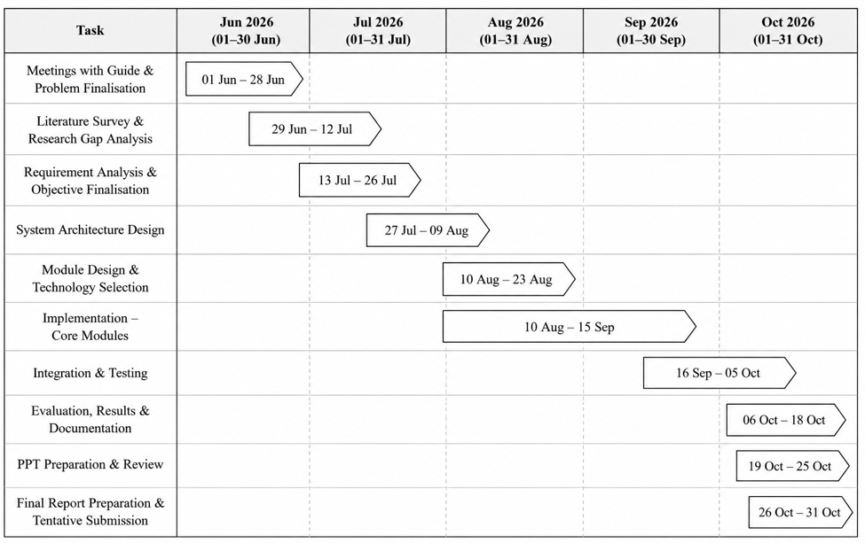
Fig. 1. Gantt chart
3. TECHNICAL SPECIFICATION
3.1 Requirements
3.1.1 Functional
- FR1: The system shall allow users to upload SRS and OpenAPI specification files.
- FR2: The system shall parse and extract individual software requirements.
- FR3: The system shall parse API endpoints, descriptions and relevant schema fields.
- FR4: The system shall generate semantic embeddings for requirements and API endpoints.
- FR5: The system shall calculate semantic similarity between requirements and API endpoints.
- FR6: The system shall generate a requirement-to-API traceability matrix.
- FR7: The system shall determine requirement compliance using configurable similarity thresholds.
- FR8: The system shall compare different API versions and detect specification drift.
- FR9: The system shall classify detected drift according to severity.
- FR10: The system shall generate natural-language explanations for detected violations.
- FR11: The system shall evaluate traceability using Precision, Recall, F1-score and MAP.
- FR12: The system shall compare transformer-based semantic matching against a TF-IDF baseline.
- FR13: The system shall simulate pull-request compliance reviews.
- FR14: The system shall provide project-based analysis through a web application.
- FR15: The system shall store and retrieve vector representations using a vector database.
3.1.2 Non-Functional
- Performance: The system should efficiently process requirements and API specifications and generate semantic similarity results with acceptable response time.
- Scalability: The architecture should support multiple projects and increasing numbers of requirements and API endpoints.
- Reliability: The system should provide consistent analysis results and robust error handling for invalid or incomplete specification files.
- Security: User projects and stored analysis data should be isolated using authentication and project-level access controls.
- Usability: The web interface should provide clear navigation and understandable traceability, drift and compliance results.
- Maintainability: The system should use modular components so that parsers, embedding models, similarity methods and analysis modules can be independently modified or extended.
- Extensibility: The framework should support additional artifact sources and alignment methods, including future integration with source-code and Git-based workflows.
- Explainability: Compliance and drift results should be accompanied by understandable explanations and remediation suggestions wherever applicable.

3.2 Feasibility Study
3.2.1 Technical Feasibility
- Technology Availability: The project uses established and readily available technologies for natural language processing, semantic analysis, API specification parsing, vector storage, and web application development. Transformer-based models such as all-mpnet-base-v2, OpenAPI parsing libraries, FastAPI, React, and Qdrant provide the required technical foundation for the proposed system.
- Technical Expertise: The project requires knowledge of Python programming, natural language processing, transformer-based embeddings, semantic similarity, API specifications, database management, and web application development. The modular architecture allows these components to be developed and integrated independently.
- Infrastructure: The system can be developed and evaluated using standard computing resources for the current datasets. Transformer embeddings can be generated locally, while vector storage and application services can be deployed using available development infrastructure. External LLM APIs can additionally be used for generating explanations.
- Integration: The proposed architecture supports integration between requirement processing, OpenAPI analysis, semantic similarity, drift detection, explainability, and pull-request review. The system is designed to further integrate with CI/CD pipelines and GitHub-based development workflows.
3.2.2 Economic Feasibility
- Cost-Benefit Analysis: The project primarily uses open-source technologies and existing development tools, keeping the development cost relatively low. Automating requirements traceability and specification compliance can reduce the manual effort required for reviewing API changes and identifying requirement violations.
- Budget: The major potential costs involve computational resources, hosting, database infrastructure, and external LLM API usage. For the current prototype and experimental datasets, these requirements are manageable using existing development resources and open-source software.
- Return on Investment (ROI): The proposed system can provide long-term benefits by reducing manual requirements verification, identifying specification drift earlier, and preventing requirement-breaking changes from progressing through the development workflow. This can reduce the effort and cost associated with detecting and correcting defects at later stages.
- Funding: The current Project-I prototype can be developed using existing academic and open-source resources without significant external funding. Future large-scale deployment may require additional resources for cloud infrastructure, continuous integration services, and model/API usage.
3.2.3 Social Feasibility
- User Acceptance: The system is designed to assist developers, requirements engineers, and software teams by presenting traceability relationships, compliance results, drift information, and explanations through an interactive interface. This can reduce repetitive manual verification while keeping the developer involved in the final decision-making process.
- Training and Support: The system is designed with an intuitive web interface that allows users to upload requirements and API specifications and view analysis results. Basic user guidance and documentation can help developers understand similarity scores, compliance classifications, drift reports, and PR-review results.
- Ethical Considerations: Since the system uses AI and LLMs for semantic analysis and explanation, the generated results should be treated as decision-support rather than unquestionable decisions. Appropriate handling of project documents and API specifications is also required to protect potentially confidential software information.
- Impact on Workforce: The proposed system is intended to augment software developers and requirements engineers rather than replace them. By automating repetitive traceability and compliance checks, it allows developers to focus more on implementation and decision-making while the system assists in identifying potential requirement violations.

3.3 System Specification
3.3.1 Hardware Specification
- Processor: 12th Generation Intel® Core™ i7-1255U processor, with 10 cores, 12 threads and up to 4.70 GHz Turbo frequency.
- Memory (RAM): 16 GB DDR4 RAM, 3200 MHz, configured as 2 × 8 GB.
- Storage: 512 GB M.2 PCIe NVMe Solid State Drive (SSD).
- Graphics Processing Unit (GPU): Integrated Intel® Iris® Xe Graphics.
- Monitor: 14-inch FHD+ (1920 × 1200) 60 Hz WVA touchscreen display
3.3.2 Software Specification
- Operating System: Windows 10/11 or compatible operating system supporting Python, Node.js, and the required development tools.
- Programming Languages: Python, JavaScript, HTML, CSS.
- Development Environment: Visual Studio Code, Python virtual environment, Node.js and npm.
- Libraries and Frameworks: FastAPI, Uvicorn, React, Vite, Sentence Transformers, NumPy, OpenAPI parsing libraries, and libraries for semantic similarity and evaluation.
- AI / NLP Models: all-mpnet-base-v2 transformer model for semantic embeddings; OpenAI and Groq APIs for LLM-assisted explanations.
- Database: SQLite for project and application data; Qdrant for vector embeddings and semantic retrieval.
- Authentication: Google OAuth and JWT-based authentication for secure user access and project isolation.
- Visualization: Interactive web-based visualization for requirement-to-API traceability relationships.
4. DESIGN APPROACH AND DETAILS
4.1 System Architecture and proposed model
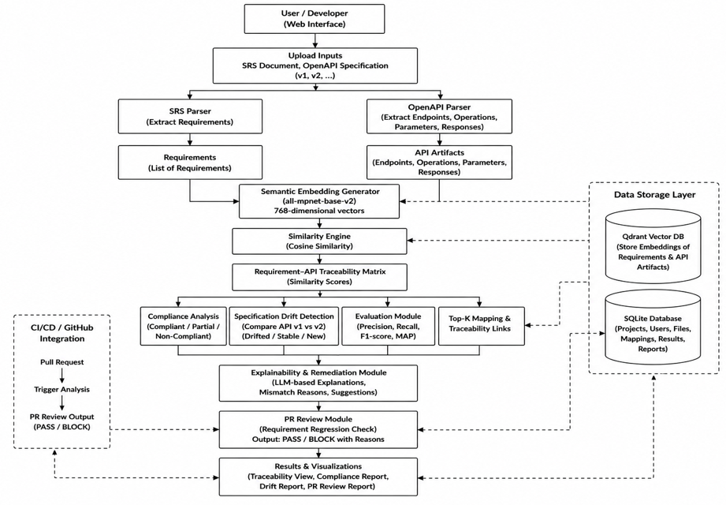
Fig. 2. System Architecture
.
The proposed system follows a modular pipeline for analyzing the semantic alignment between software requirements and API specifications. The user provides an SRS document and one or more OpenAPI specifications, which are processed by the respective parsers to extract requirements and API artifacts such as endpoints, operations, parameters, and responses. These artifacts are converted into 768-dimensional semantic embeddings using the all-mpnet-base-v2 transformer model.
The Similarity Engine uses cosine similarity to compare requirements with API artifacts and generates a Requirement–API Traceability Matrix. The resulting alignment scores are used by the Compliance Analysis module to classify requirements as compliant, partially compliant, or non-compliant. The Specification Drift Detection module compares different API versions to identify changes in semantic alignment. The Evaluation Module measures traceability performance using Precision, Recall, F1-score, and MAP, while the Top-K Mapping module identifies the most relevant API endpoints for each requirement.
The framework follows a baseline-driven approach, where the original software requirements serve as the reference against which different API specifications and their subsequent versions are evaluated. This allows changes in API specifications to be analyzed without manually recreating traceability relationships for every version. Configurable similarity thresholds are used to determine the level of alignment between requirements and API endpoints. The Top-K mapping functionality is useful when a requirement is associated with multiple endpoints or when the strongest individual match does not completely represent the requirement.
For specification evolution, the same requirement baseline is evaluated against different API versions. The resulting alignment scores are compared to calculate changes in semantic similarity and identify potential regressions. The drift detection process considers changes in API specifications, including modified, removed, and newly introduced endpoints, and determines their effect on requirement alignment. This enables potentially problematic specification changes to be identified at an early stage of development.
The analysis results are passed to the Explainability and Remediation Module, which provides LLM-assisted explanations of detected mismatches and possible corrective actions. Instead of presenting only similarity scores or compliance classifications, the module helps describe the affected requirement, relevant API functionality, identified mismatch, and possible remediation. The numerical compliance decision remains independent of the generated explanation, allowing the language model to assist developers without directly determining the compliance score.
The system uses a clear separation between data processing, semantic analysis, decision-making, storage, and presentation layers. The React frontend provides the user interface, while the FastAPI backend connects the interface with the parsing, embedding, similarity, drift, evaluation, and explanation modules. Qdrant is used for storing semantic embeddings, while SQLite maintains project, user, file, mapping, and analysis data. The web interface presents traceability, compliance, drift, and PR-review results through interactive visualizations.
The PR Review Module uses the analysis results to identify requirement regressions and generate PASS/BLOCK decisions for proposed changes. The architecture is designed to support integration with modern development workflows, with CI/CD and GitHub integration planned to automate the analysis during pull-request processing. Overall, the architecture provides an integrated workflow from requirement extraction to semantic representation, traceability analysis, compliance assessment, specification drift detection, explainability, and pull-request review, while providing a foundation for extending the framework to additional software artifacts and automated development workflows.
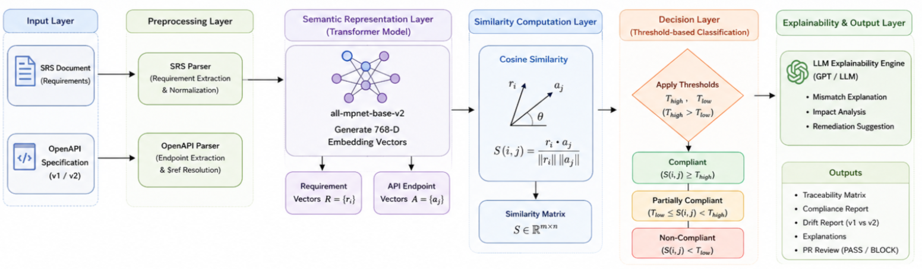
Figure 3. Proposed model

The proposed system uses a hybrid semantic traceability and specification drift analysis model that combines transformer-based semantic embeddings, cosine similarity, threshold-based classification, and LLM-assisted explainability. Unlike a conventional supervised classification model, the proposed approach does not require a separate training dataset for similarity computation. It uses the all-mpnet-base-v2 transformer model to represent software requirements and API endpoints as 768-dimensional vectors in a common semantic space. This enables the system to capture contextual and semantic relationships between requirements and API specifications beyond simple keyword matching.
Let the set of requirements be represented by $R=\left\{r_{1} , r_{2} , … , r_{m}\right\}$and the set of API endpoints by $A=\left\{a_{1} , a_{2} , … , a_{n}\right\}$. Each requirement and API endpoint is converted into an embedding vector using the transformer encoder. The semantic relationship between a requirement $r_{i}$and an API endpoint $a_{j}$is calculated using cosine similarity:
$$S\left(i , j\right)=\frac{r_{i}⋅a_{j}}{∥r_{i}∥∥a_{j}∥}$$
The resulting similarity values form a requirement-to-API similarity matrix, which is used to generate the traceability matrix and Top-K mappings. Configurable thresholds are then applied to classify the relationship into compliant, partially compliant, or non-compliant categories. If $T_{high}$and $T_{low}$represent the upper and lower similarity thresholds, the classification is defined as:
$$C\left(i , j\right)=\left\{\begin{matrix}1, & S\left(i , j\right)≥T_{high} \\ 0.5, & T_{low}≤S\left(i , j\right)<T_{high} \\ 0, & S\left(i , j\right)<T_{low}\end{matrix}\right.$$
For specification drift analysis, the same requirement baseline is compared against two API versions, $v1$and $v2$. The similarity matrices obtained from the two versions are compared to determine changes in requirement-to-API alignment. A requirement-level drift score can be represented as the average change in similarity across its associated API endpoints:
$$D_{i}=\frac{1}{n}\sum_{j=1}^{n}{∣}S^{\left(1\right)}\left(i , j\right)-S^{\left(2\right)}\left(i , j\right)∣$$
where a higher value indicates a greater change in semantic alignment and therefore a higher potential for specification drift. The overall drift can subsequently be obtained by aggregating the drift scores across requirements.
The final component of the hybrid model is the LLM-based explainability layer. The numerical similarity and compliance results are generated deterministically by the embedding and similarity pipeline, while the LLM is used to explain detected mismatches, describe the impact of specification changes, and provide remediation suggestions. Thus, the proposed model combines semantic representation, mathematical similarity computation, interpretable threshold-based decisions, cross-version drift measurement, and generative explainability to provide an end-to-end approach for requirements traceability and specification drift analysis.

4.2 Design

4.2.1 Data Flow Diagram
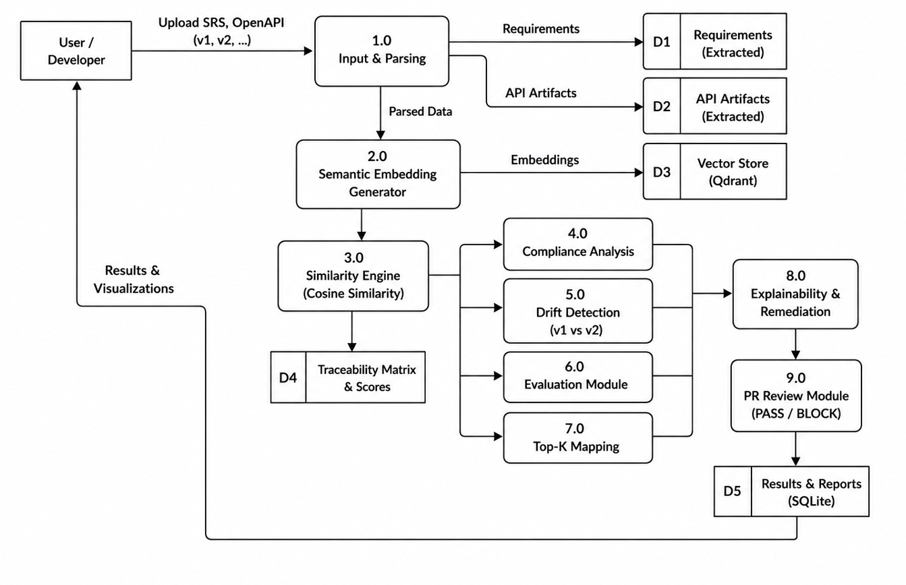

4.2.2 Use Case Diagram
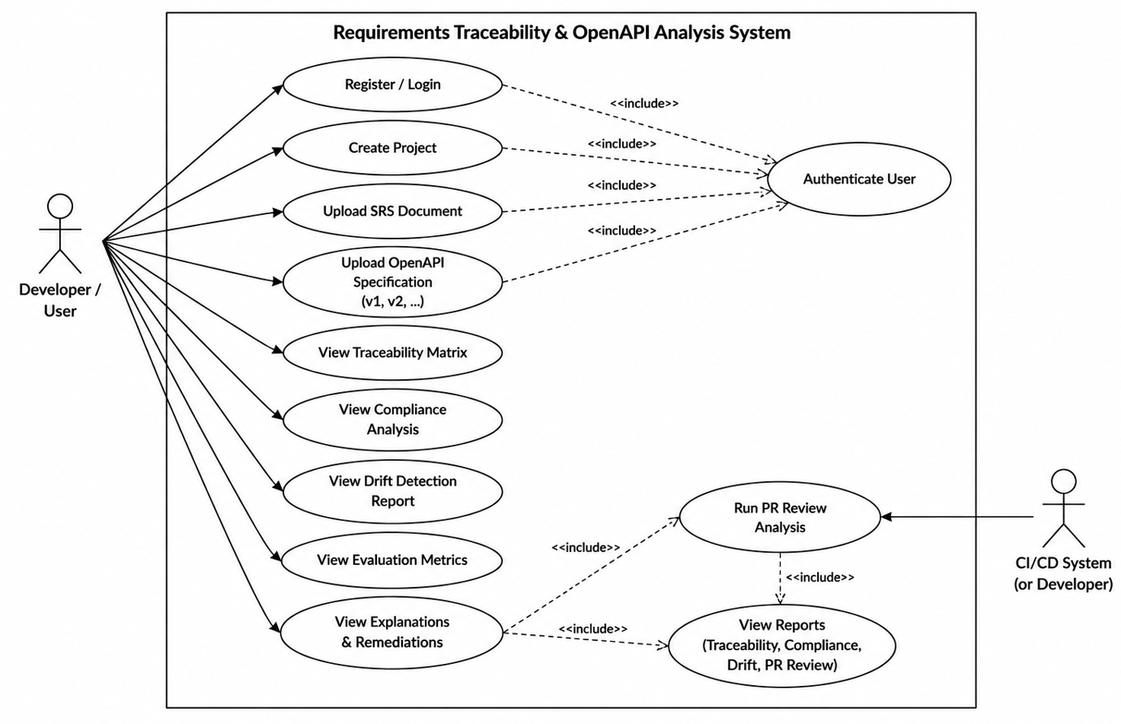

4.2.3 Class Diagram
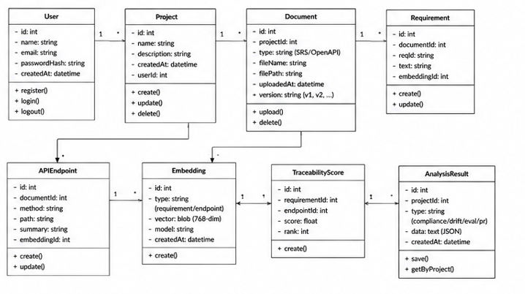

4.2.4 Sequence Diagram
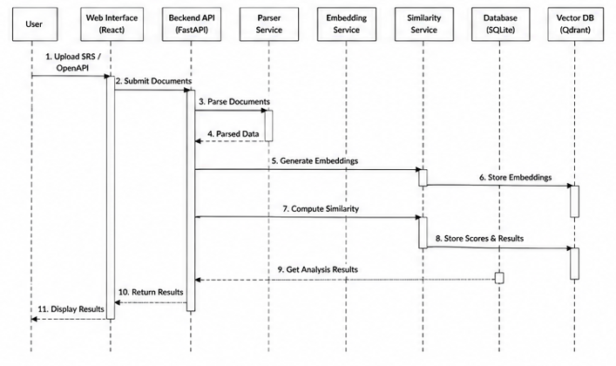

5. REFERENCES
Weblinks:
- https://www.sbert.net/
- https://fastapi.tiangolo.com/
- https://spec.openapis.org/oas/latest.html
- https://qdrant.tech/documentation/
- https://www.sqlite.org/docs.html

Journals:
- Lin, J., Liu, Y., Zeng, Q., Jiang, M., and Cleland-Huang, J., "Traceability Transformed: Generating More Accurate Links with Pre-Trained BERT Models," Proceedings of the 43rd IEEE/ACM International Conference on Software Engineering (ICSE), Madrid, Spain, 2021, pp. 324–335.
- Peng, T., She, K., Shen, Y., Xu, X., and Yu, Y., "Enhancing Traceability Link Recovery with Fine-Grained Query Expansion Analysis," Information, vol. 14, no. 5, Art. no. 270, 2023.
- Uzun, B. and Tekinerdogan, B., "Detecting Deviations in the Code Using Architecture View-Based Drift Analysis," Computer Standards & Interfaces, vol. 87, Art. no. 103774, 2024.
- Dai, P., Yang, L., Wang, Y., Jin, D., and Gong, Y., "Constructing Traceability Links between Software Requirements and Source Code Based on Neural Networks," Mathematics, vol. 11, no. 2, Art. no. 315, 2023, doi: 10.3390/math11020315.
- Majidzadeh, A., Ashtiani, M., and Zakeri-Nasrabadi, M., "Multi-type Requirements Traceability Prediction by Code Data Augmentation and Fine-Tuning MS-CodeBERT," Computer Standards & Interfaces, vol. 90, Art. no. 103850, 2024, doi: 10.1016/j.csi.2024.103850.
- Alturayeif, N., Hassine, J., and Ahmad, I., "Machine Learning Approaches for Automated Software Traceability: A Systematic Literature Review," Journal of Systems and Software, vol. 230, Art. no. 112536, 2025, doi: 10.1016/j.jss.2025.112536.
- Alturayeif, N., Ahmad, I., and Hassine, J., "TraceLLM: Leveraging Large Language Models with Prompt Engineering for Enhanced Requirements Traceability," Requirements Engineering, vol. 31, no. 1, Art. no. 6, 2026, doi: 10.1007/s00766-026-00460-1.

Conference:
- Feldt, R. and Coppola, R., "Semantic API Alignment: Linking High-Level User Goals to APIs," in Proceedings of the IEEE/ACM International Workshop on Natural Language-Based Software Engineering (NLBSE), Ottawa, Canada, 2025, pp. 17–20.
- Sundberg, E., Ekmark, T., and Ayele, W. Y., "Validating API Design Requirements for Interoperability: A Static Analysis Approach Using OpenAPI," in Proceedings of the Practice of Enterprise Modeling Forum (PoEM Forum), Geneva, Switzerland, 2025, pp. 100–105.
- Alhoshan, W., Batista-Navarro, R. T., and Zhao, L., "Semantic Frame Embeddings for Detecting Relations between Software Requirements," in Proceedings of the 13th International Conference on Computational Semantics - Student Papers (IWCS), Gothenburg, Sweden, 2019, pp. 44–51, doi: 10.18653/v1/W19-0606.
- Hey, T., Chen, F., Weigelt, S., and Tichy, W. F., "Improving Traceability Link Recovery Using Fine-Grained Requirements-to-Code Relations," in Proceedings of the 43rd IEEE/ACM International Conference on Software Engineering (ICSE), Madrid, Spain, 2021, pp. 289–301.

Technical / AI Reference:
- Reimers, N. and Gurevych, I., "Sentence-BERT: Sentence Embeddings using Siamese BERT-Networks," in Proceedings of the 2019 Conference on Empirical Methods in Natural Language Processing and the 9th International Joint Conference on Natural Language Processing (EMNLP-IJCNLP), Hong Kong, China, 2019, pp. 3982–3992.
- Reimers, N. and Gurevych, I., "Making Monolingual Sentence Embeddings Multilingual Using Knowledge Distillation," in Proceedings of the 2020 Conference on Empirical Methods in Natural Language Processing (EMNLP), 2020, pp. 4512–4525.
Book:
- Sommerville, I., Software Engineering, 10th ed., Pearson, 2015.

